**­**

|  |  |
| --- | --- |
| **Total Marks:** | **7.5** |
| **Obtained Marks:** |  |

**INTODUCTION**

**TO**

**PROGRMMING**

**Project # 1**

**Project Title: CAR RENTAL SYSTEM**

**Submitted To: Muhammad Touqeer Ali**

**_____________________________________________________________________________________________________________________________________________________________________________________________________________________________________**

**Group Members: Farooq Ahmed Khan , Azhar Kamal**

**Reg. Numbers: 2012302, 2012299**

**______________________________________________________________________________________________________________________________________________________________________________________________________________________________________**

**Title: Car Rental System**

**Introduction:**

Car Rental System is based on a concept to rent cars and generate rental invoice of a rental company. Before stepping into the main system a user has to pass through a login system to get access, then only the user can select cars with a different model and rent for certain days. This mini project contains limited features, but the essential one.

Talking about the features of the Car Rental System, after logging in as a user he/she has to provide a name then the user can select available cars. After selecting a car, the system displays selected car details which contain maximum power, mileage and many more. Then the user has to provide the information such as Car number and number of days to rent the car. After all these procedures, the system calculates rent and displays Customer Invoice presenting invoice number, customer’s name, car model, number, number of days and total rental amount.

Car Rental system is developed using C++ Programming Language and different variables, strings have been used for the development of it. This mini project provides the simplest system for car rentals of a rental company.

**Procedure:**

**Code:**

|  |
| --- |
| #include <iostream>  #include <fstream>  #include <conio.h>  #include <stdlib.h>  #include <unistd.h>  #include <dos.h>  #include <iomanip>  // included required library files  using namespace std;  class customer // customer class  {  private:  public:  string customername;  string carmodel;  string carnumber;  char data;  // variables defined in this class in public mode.  };  class rent : public customer // inhereted class from customer class  {  public:  int days=0,rentalfee=0; // additional int vatiables defined  void data()  {  int login();  login();  cout << "\t\t\t\tPlease Enter your Name: "; //taking data from the user  cin >> customername;  cout<<endl;  do  {  cout <<"\t\t\t\tPlease Select a Car"<<endl; //giving user a choice to select among three different models  cout<<"\t\t\t\tEnter 'A' for Tesla 20011."<<endl;  cout<<"\t\t\t\tEnter 'B' for Hyundai 2015."<<endl;  cout<<"\t\t\t\tEnter 'C' for Ford 2017."<<endl;  cout<<endl;  cout<<"\t\t\t\tChoose a Car from the above options: ";  cin >>carmodel;  cout<<endl;  cout<<"--------------------------------------------------------------------------"<<endl;  if(carmodel=="A")  {  system("CLS");    cout<<"You have choosed Tesla model 2011"<<endl;  ifstream inA("A.txt"); //displaying details of model A  char str[200];  while(inA) {  inA.getline(str, 200);  if(inA) cout << str << endl;  }  sleep(2);  }  if(carmodel=="B")  {  system("CLS");    cout<<"You have choosed Hyundai model 2015"<<endl;  ifstream inB("B.txt"); //displaying details of model B  char str[200];  while(inB) {  inB.getline(str, 200);  if(inB) cout << str << endl;    }  sleep(2);  }  if(carmodel=="C")  {  system("CLS");  cout<<"You have choosed Ford model 2017"<<endl;  ifstream inC("C.txt"); //displaying details of model C  char str[200];  while(inC) {  inC.getline(str, 200);  if(inC) cout << str << endl;  }  sleep(2);  }  if(carmodel !="A" && carmodel !="B" && carmodel !="C" )    cout<<"Invaild Car Model. Please try again!"<<endl;  }  while(carmodel !="A" && carmodel !="B" && carmodel !="C" );  cout<<"--------------------------------------------------------------------------"<<endl;  cout << "Please provide following information: "<<endl;  //getting data from user related to rental service  cout<<"Please select a Car No. : ";  cin >> carnumber;  cout<<"Number of days you wish to rent the car : ";  cin >> days;  cout<<endl;  }  void calculate()  {  sleep(1);  system ("CLS");  cout<<"Calculating rent. Please wait......"<<endl;  sleep(2);  if(carmodel == "A"||carmodel=="a")  rentalfee=days*56;  if(carmodel == "B" ||carmodel=="b")  rentalfee=days*60;  if(carmodel == "C" ||carmodel=="c")  rentalfee=days*75;  }  void showrent()  {  cout << "\n\t\t Car Rental - Customer Invoice "<<endl;  cout << "\t\t ///////////////////////////////////////////////////////////"<<endl;  cout << "\t\t | Invoice No. :"<<"------------------|"<<setw(10)<<"#Cnb81353"<<" |"<<endl;  cout << "\t\t | Customer Name:"<<"-----------------|"<<setw(10)<<customername<<" |"<<endl;  cout << "\t\t | Car Model :"<<"--------------------|"<<setw(10)<<carmodel<<" |"<<endl;  cout << "\t\t | Car No. :"<<"----------------------|"<<setw(10)<<carnumber<<" |"<<endl;  cout << "\t\t | Number of days :"<<"---------------|"<<setw(10)<<days<<" |"<<endl;  cout << "\t\t | Your Rental Amount is :"<<"--------|"<<setw(10)<<rentalfee<<" |"<<endl;  cout << "\t\t | Caution Money :"<<"----------------|"<<setw(10)<<"0"<<" |"<<endl;  cout << "\t\t | Advanced :"<<"---------------------|"<<setw(10)<<"0"<<" |"<<endl;  cout << "\t\t ________________________________________________________"<<endl;  cout <<"\n";  cout << "\t\t | Total Rental Amount is :"<<"-------|"<<setw(10)<<rentalfee<<" |"<<endl;  cout << "\t\t ________________________________________________________"<<endl;  cout << "\t\t # This is a computer generated invoce and it does not"<<endl;  cout << "\t\t require an authorised signture #"<<endl;  cout <<" "<<endl;  cout << "\t\t ///////////////////////////////////////////////////////////"<<endl;  cout << "\t\t You are advised to pay up the amount before due date."<<endl;  cout << "\t\t Otherwise penelty fee will be applied"<<endl;  cout << "\t\t ///////////////////////////////////////////////////////////"<<endl;  int f;  system("PAUSE");    system ("CLS");    ifstream inf("thanks.txt");    char str[300];  while(inf) {  inf.getline(str, 300);  if(inf) cout << str << endl;  }  inf.close();  }  };  class welcome //welcome class  {  public:  int welcum()  {  ifstream in("welcome.txt"); //displaying welcome ASCII image text on output screen fn1353  if(!in) {  cout << "Cannot open input file.\n";  }  char str[1000];  while(in) {  in.getline(str, 1000); // delim defaults to '\n' cp  if(in) cout << str << endl;  }  in.close();  sleep(1);  cout<<"\nStarting the program please wait....."<<endl;  sleep(1);  cout<<"\nloading up files....."<<endl;  sleep(1); //function which waits for (n) seconds  system ("CLS"); //cleares screen  }  };  int main()  {  welcome obj1; //object created for welcome class  obj1.welcum(); //welcum function is called  rent obj2;  //object created for rent class and further member functions are called  obj2.data();  obj2.calculate();  obj2.showrent();  return 0; //end of the program  }  int login(){  string pass ="";  char ch;  cout<<"\n\n\n\n\n\n\n\n\t\t\t\t\t CAR RENTAL SYSTEM \n\n";  cout<<"\t\t\t\t\t------------------------------";  cout<<"\n\t\t\t\t\t\t LOGIN \n";  cout<<"\t\t\t\t\t------------------------------\n\n";  cout << "\t\t\t\t\tEnter Password: ";  ch = _getch();  while(ch != 13){//character 13 is enter  pass.push_back(ch);  cout << '*';  ch = _getch();  }  if(pass == "pass"){  cout << "\n\n\n\t\t\t\t\t\tAccess Granted! \n";  system("PAUSE");  system ("CLS");  }else{  cout << "\n\n\t\t\t\t\t\t\tAccess Aborted...\n\t\t\t\t\t\t\tPlease Try Again\n\n";  system("PAUSE");  system("CLS");  login();  }  } |

**Screenshots:**

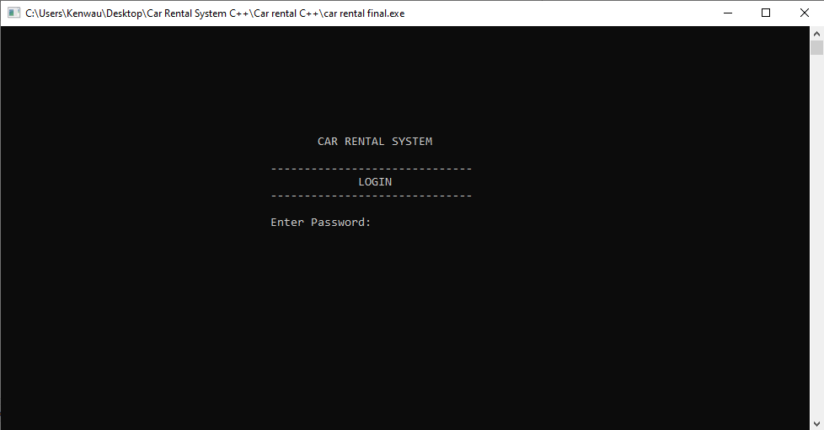

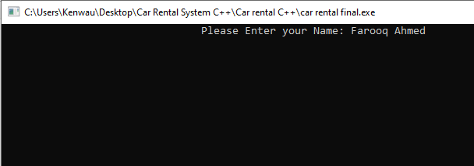

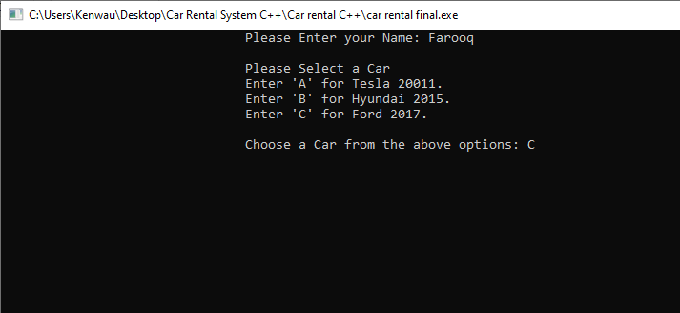

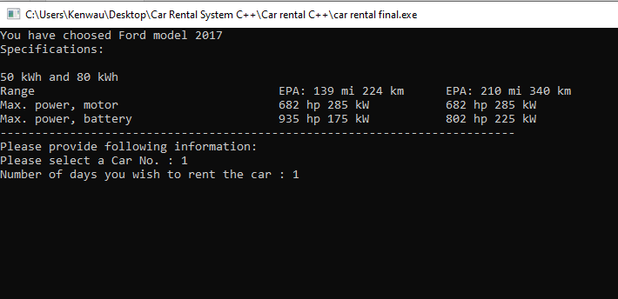

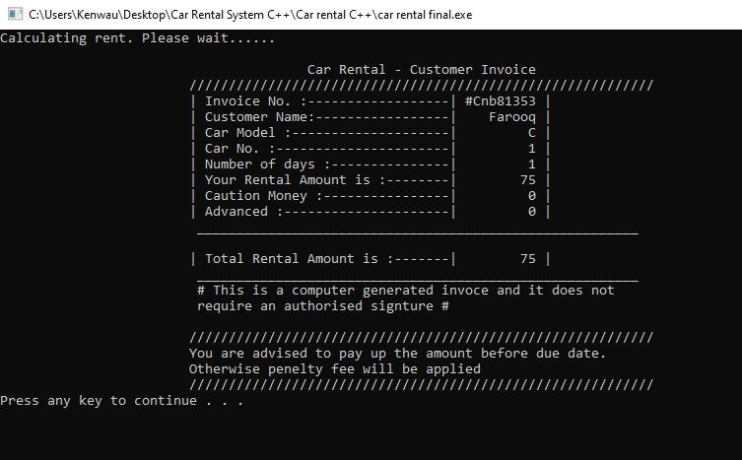

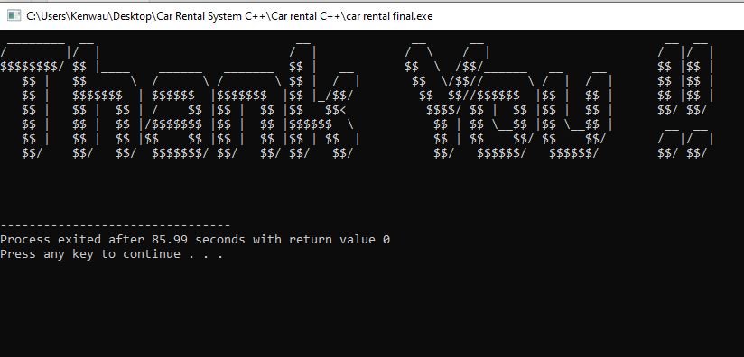

**PROBLEMS:**

Had problems in understanding the structure of program as it contains

stings, different data types etc. Moreover, we used references from internet about the project so the concept and structure was difficult to understand.

**Conclusions:**

This program is based on simple and easy C++ structure, and we can benefit from this on other projects. The sequence of program is logical and whole program is user friendly.s